Candidate’s Name: ………………………………………………………… Assessment Number: …………………………………………
School Name: ……………………………………………………………………. School Code: …………………………………………………………
Candidate’s Signature: ………………………………..…………….Date: …………………………………………………….…………….
COMPETENCE BASED EDUCATION
KENYA JUNIOR SCHOOL EDUCATION ASSESSMENT
906/1 AGRICULTURE AND NUTRITION (Theory)
PAPER 1 YEAR 20__ Time: 1 hour 40 minutes
INSTRUCTIONS TO CANDIDATES
- Fill in all the details above.
- This paper consists of two sections: A and B.
- Section A comprises Multiple Choice Questions numbered 1 to 30.
- Section B comprises short, structured questions number 31 to 42.
- Answer ALL the questions in section A on the separate ANSWER SHEET provided.
- Answer ALL the questions in section B in the spaces provided in this QUESTION PAPER.
- Do NOT remove any page from this question paper.
- Answer ALL the questions in English.
For official use only SECTION B
Task | Question | Maximum score | Candidate’s score | Total per task
Task 1: Agriculture | 31 | 3
 | 32 | 3
 | 33 | 3
 | 34 | 3
 | 35 | 4
 | 36 | 4
 | 37 | 4
Task 2: Nutrition | 38 | 2
 | 39 | 2
 | 40 | 5
 | 41 | 2
 | 42 | 5

This paper consists of 10 printed pages. Candidates should check the question paper to ascertain that all the pages are printed as indicated and that no questions are missing. © 2025 The competence based assessment Turn over

SECTION A (30 marks)
Answer ALL the questions in this section.
Please read these instructions carefully
- You have been given this question paper and a separate answer sheet. This section consists of 30 multiple choice questions.
- Answer ALL questions in this section on the ANSWER SHEET provided, NOT on the question paper.
- Do all the necessary rough work on the question paper.
HOW TO USE THE ANSWER SHEET
- Use an ordinary HB pencil.
- Confirm that the answer sheet you have been provided with has the following: YOUR ASSESSMENT NUMBER YOUR NAME NAME OF YOUR SCHOOL NAME OF THE SUBJECT
- Keep the answer sheet clean and dry. DO NOT fold it.
- For each of the questions 1 – 30, four answers are given. The answers are lettered A, B, C and D. In each case, only ONE of the four choices is correct. Choose the correct answer.
- On the answer sheet, the correct answer is to be shown by drawing a DARK LINE inside the box in which the letter you have chosen is written.
Example
In the Question Paper:
- Nairobi City dwellers put garbage at designated areas. The huge amounts of garbage are collected by trucks and deposited at the Dandora dumpsite. This pollutes soil mainly by
A. agricultural chemical wastes. B. artificial fertilizer application. C. plastic wastes. D. waste water.
The correct answer is ‘C’.
On the answer sheet, In the set of boxes numbered 17, draw a DARK LINE inside the box with the letter C printed in it as marked below.
- [A] [B] [C] [D]
- Your dark line MUST be inside the box. DO NOT make any marks outside the boxes.
- For each question, ONLY ONE box is to be marked.

SECTION A (30 marks)
Answer ALL the questions in this section.

- Which one of the following is a benefit of establishing woodlots in a school compound? A. Increased soil erosion. B. Provision of timber for sale. C. Improved aesthetic value. D. Increased wild animal population.
- A farmer observed that the leaves of his sukumawiki wiki crop were turning yellow. This is likely caused by a deficiency of which nutrient? A. Phosphorus. B. Potassium. C. Nitrogen. D. Calcium.
- Which one of the following methods of soil conservation is most suitable for steep slopes? A. Mulching. B. Terracing. C. Grass stripping. D. Cover cropping.

Study the diagram below showing a method of water harvesting and conservation.
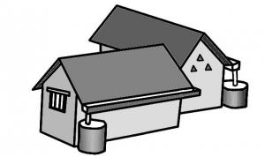
Use it to answer questions 4 and 5.

- Identify the method of water harvesting shown in the diagram. A. Farm pond. B. Weir. C. Earth dam. D. Roof catchment.
- Which one of the following is a disadvantage of the water harvesting method shown? A. It requires a large area of land. B. The water collected may be contaminated. C. It is only suitable for flat areas. D. It does not collect enough water for domestic use.
- Which one of the following is a physical method of pest control in crop production? A. Use of scarecrows. B. Spraying with pesticides. C. Crop rotation. D. Use of resistant varieties.

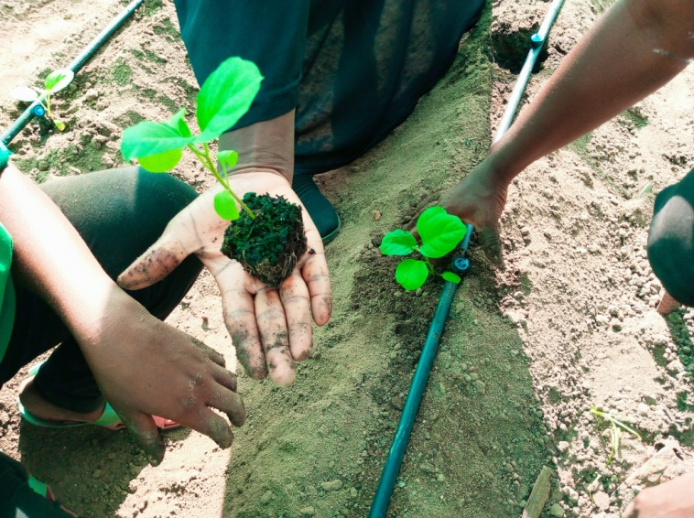
The following picture shows a common practice in vegetable farming. Use it to answer questions 7 and 8.

- Identify the practice shown in the picture. A. Weeding. B. Thinning. C. Gapping. D. Transplanting.
- Which one of the following tools is most suitable for carrying out the practice shown in the picture? A. Garden trowel. B. Fork hoe. C. Jembe. D. Rake.
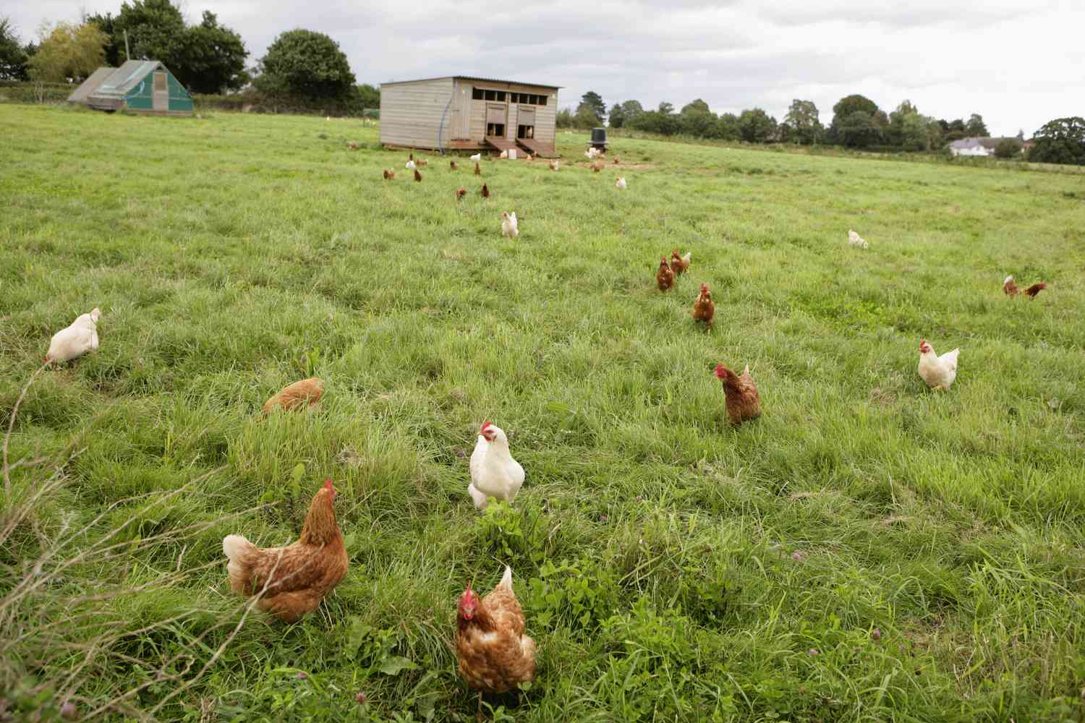
- A farmer is keeping poultry under the free-range system. Which one of the following is an advantage of this system?

A. High egg production. B. Easy control of diseases and pests. C. Low feeding costs. D. Requires less space.
- Which one of the following is a sign of a healthy animal? A. Dull coat. B. Standing away from the group. C. Bright eyes. D. Loss of appetite.
- Which one of the following is a legume crop commonly grown in Kenya? A. Maize. B. Cabbage. C. Beans. D. Irish potato.
- Integrated farming involves combining different farming enterprises on the same farm. Which of the following combinations represents integrated farming? A. Growing maize and beans. B. Rearing dairy cattle and sheep. C. Growing vegetables and keeping poultry. D. Growing coffee and tea.
- Pruning is a caring practice in fruit tree farming. What is the main purpose of pruning?
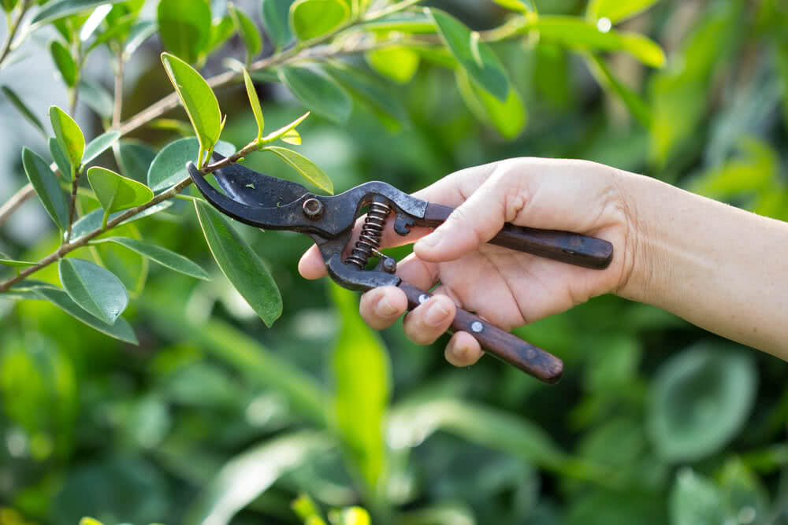
A. To control pests and diseases. B. To encourage vegetative growth. C. To remove unwanted branches. D. To increase the number of fruits.
- Which one of the following is a tool used for harvesting maize? A. Panga. B. Sickle. C. Hoe. D. Shears.
- Crop rotation is practiced to maintain soil fertility and control pests and diseases. Which of the following is a correct sequence for a simple crop rotation plan? A. Maize -> Cabbage -> Beans. B. Beans -> Maize -> Cabbage. C. Cabbage -> Beans -> Maize. D. Maize -> Beans -> Cabbage.
- Which one of the following is the main function of carbohydrates in the diet? A. Building and repairing body tissues. B. Providing energy. C. Protecting the body against diseases. D. Regulating body processes.

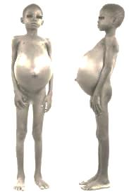
- Kwashiorkor is a deficiency disease caused by lack of which nutrient?

A. Vitamins. B. Minerals. C. Carbohydrates. D. Proteins.
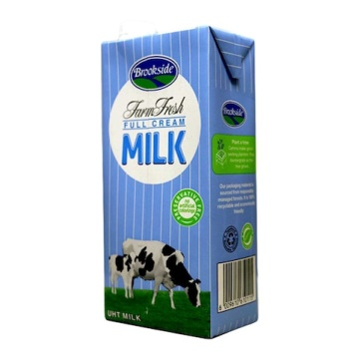
- Which of the following foods is a good source of Vitamin C?
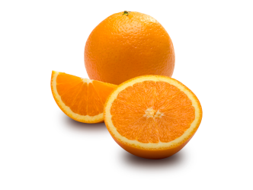
A B

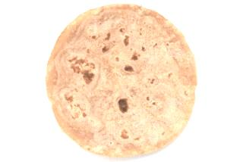
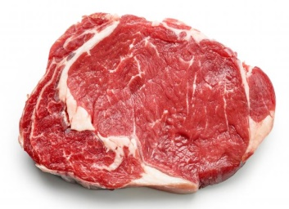

C D

- What is the main reason for adding yeast when making bread? A. To add colour. B. To improve taste. C. To make the dough rise. D. To preserve the bread.
- Which one of the following cooking methods involves cooking food in hot oil or fat? A. Boiling. B. Steaming. C. Frying. D. Baking.
- Blanching is a pre-treatment method for preserving vegetables. What is the main purpose of blanching? A. To improve the flavour. B. To inactivate enzymes. C. To add colour. D. To reduce cooking time.
- Which of the following is a correct practice for storing dry foodstuff like flour and sugar? A. Storing in open containers to allow air circulation. B. Storing in damp places to prevent drying. C. Storing in airtight containers in a cool, dry place. D. Storing near the cooking area for easy access.
- What is the main purpose of garnishing a meal? A. To increase the nutritional value. B. To improve the appearance and appeal. C. To make the food last longer. D. To reduce the cost of the meal.
- Which food serving style is suitable for a large group of people where food is arranged on a table and people serve themselves? A. Plate service. B. Family service. C. Buffet service. D. Silver service.
- Which one of the following materials is most suitable for cleaning greasy kitchen surfaces? A. Cold water and detergent. B. Hot water and detergent. C. Cold water only. D. Hot water only.
- Disinfecting a toilet bowl helps to: A. Remove stains. B. Kill germs. C. Remove bad smell. D. Make it shine.
- Which of the following is a tool used for sweeping floors? A. Mop. B. Bucket. C. Dustpan. D. Broom.
- What is the primary reason for airing bedding daily? A. To remove dust. B. To make it smell fresh. C. To kill bedbugs. D. To save energy.
- Which of the following sewing tools is used for cutting fabric? A. Pins. B. Needles. C. Scissors. D. Tape measure.
- Which one of the following stitches is used for joining two pieces of fabric together permanently? A. Basting stitch. B. Hemming stitch. C. Running stitch. D. Back stitch.

SECTION B (40 marks)
Answer ALL the questions in this section.
- Soil erosion is a major problem in agriculture. (a) Define the term soil erosion. (1 mark)
________________________________________________________________________
________________________________________________________________________
(b) Give two agents of soil erosion. (2 marks)
________________________________________________________________________
________________________________________________________________________
- Crop pests can cause significant damage to crops. (a) State one way in which pests damage crops. (1 mark)
________________________________________________________________________
________________________________________________________________________
(b) Outline two cultural methods of controlling crop pests. (2 marks)
________________________________________________________________________
________________________________________________________________________
- A farmer wants to establish a small fish pond on their farm. (a) State one reason why a farmer would keep fish. (1 mark)
________________________________________________________________________
________________________________________________________________________
(b) Outline two factors the farmer should consider when locating the fish pond. (2 marks)
________________________________________________________________________
________________________________________________________________________
- Integrated pest management (IPM) is a modern approach to controlling pests. (a) What is integrated pest management? (1 mark)
________________________________________________________________________
________________________________________________________________________
(b) Give two benefits of using IPM compared to relying only on chemical pesticides. (2 marks)
________________________________________________________________________
________________________________________________________________________
- Forage conservation is important for livestock farmers. (a) Name two types of forage that can be conserved. (2 marks)
________________________________________________________________________
________________________________________________________________________
(b) Give two reasons for conserving forage. (2 marks)
________________________________________________________________________
________________________________________________________________________
- Livestock require different types of feeds for healthy growth and production. (a) Name two classes of livestock feeds. (2 marks)
________________________________________________________________________
________________________________________________________________________
(b) Give two examples of maintenance feeds for cattle. (2 marks)
________________________________________________________________________
________________________________________________________________________
- A school garden is being established by Grade 7 learners. (a) Outline two safety precautions the learners should observe when using garden tools. (2 marks)
________________________________________________________________________
________________________________________________________________________
(b) Give two advantages of establishing a school garden. (2 marks)
________________________________________________________________________
________________________________________________________________________
- Maintaining proper hygiene in the kitchen is essential for food safety. Outline two daily cleaning activities carried out in a kitchen. (2 marks)
________________________________________________________________________
________________________________________________________________________
- Ironing is done to remove creases from clothes. Outline two reasons for ironing clothes. (2 marks)
________________________________________________________________________
________________________________________________________________________
- Meal planning is an important skill in nutrition. (a) State two reasons for planning meals. (2 marks)
________________________________________________________________________
________________________________________________________________________
(b) Suggest three food items that could be included in a healthy breakfast for a school-going child. (3 marks)
________________________________________________________________________
________________________________________________________________________
________________________________________________________________________
- Disinfectants are used in cleaning. Outline two places in a home where disinfectants should be used. (2 marks)
________________________________________________________________________
________________________________________________________________________
- You are preparing scrambled eggs for breakfast. (a) Outline two ingredients you will need besides eggs. (2 marks)
________________________________________________________________________
________________________________________________________________________
(b) Highlight three qualities of well-cooked scrambled eggs. (3 marks)
________________________________________________________________________
________________________________________________________________________
________________________________________________________________________
THIS IS THE LAST PRINTED PAGE.
ANSWERS
Section A (30 marks)
Answer ALL the questions in this section on the separate answer sheet provided.
- Which one of the following is a benefit of establishing woodlots in a school compound?
  - B. Provision of timber for sale. (While woodlots can improve aesthetics, their primary benefit is often the provision of wood.)
- A farmer observed that the leaves of his sukumawiki crop were turning yellow. This is likely caused by a deficiency of which nutrient?
  - C. Nitrogen. (Yellowing of leaves, especially older ones, is a common symptom of nitrogen deficiency.)
- Which one of the following methods of soil conservation is most suitable for steep slopes?
  - B. Terracing. (Terraces create level steps that reduce water runoff and soil erosion on steep slopes.)
Study the diagram below showing a method of water harvesting and conservation.
- Identify the method of water harvesting shown in the diagram.
  - C. Earth dam. (The diagram depicts a barrier built across a waterway to trap water.)
- Which one of the following is a disadvantage of the water harvesting method shown?
  - B. The water collected may be contaminated. (Open water bodies like earth dams are susceptible to pollution.)
- Which one of the following is a physical method of pest control in crop production?
  - A. Use of scarecrows. (Scarecrows are physical barriers or deterrents.)
The following picture shows a common practice in vegetable farming. Use it to answer questions 7 and 8.
- Identify the practice shown in the picture.
  - D. Transplanting. (The picture shows seedlings being moved from a nursery to a planting bed.)
- Which one of the following tools is most suitable for carrying out the practice shown in the picture?
  - A. Garden trowel. (A trowel is ideal for making small holes for transplanting seedlings.)
- A farmer is keeping poultry under the free-range system. Which one of the following is an advantage of this system?
  - C. Low feeding costs. (Free-range birds can forage for some of their food.)
- Which one of the following is a sign of a healthy animal?
  - C. Bright eyes. (Dull coat, isolation, and loss of appetite are signs of illness.)
- Which one of the following is a legume crop commonly grown in Kenya?
  - C. Beans. (Legumes are plants in the family Fabaceae, and beans are a common example.)
- Integrated farming involves combining different farming enterprises on the same farm. Which of the following combinations represents integrated farming?
  - C. Growing vegetables and keeping poultry. (This allows for potential synergies, like using poultry manure as fertilizer for vegetables.)
- Pruning is a caring practice in fruit tree farming. What is the main purpose of pruning?
  - C. To remove unwanted branches. (Pruning helps shape the tree, improve airflow, and increase fruit production.)
- Which one of the following is a tool used for harvesting maize?
  - A. Panga. (A panga is a common tool for cutting maize stalks.)
- Crop rotation is practiced to maintain soil fertility and control pests and diseases. Which of the following is a correct sequence for a simple crop rotation plan?
  - B. Beans -> Maize -> Cabbage. (Legumes like beans fix nitrogen in the soil, benefiting subsequent crops.)
- Which one of the following is the main function of carbohydrates in the diet?
  - B. Providing energy. (Carbohydrates are the body's primary source of energy.)
- Kwashiorkor is a deficiency disease caused by lack of which nutrient?
  - D. Proteins. (Kwashiorkor is a form of malnutrition resulting from protein deficiency.)
- Which of the following foods is a good source of Vitamin C?
  - A. (The image shows citrus fruits, which are rich in Vitamin C.)
- What is the main reason for adding yeast when making bread?
  - C. To make the dough rise. (Yeast produces carbon dioxide, which causes the dough to leaven.)
- Which one of the following cooking methods involves cooking food in hot oil or fat?
  - C. Frying. (Frying is the process of cooking food by immersing it in hot oil or fat.)
- Blanching is a pre-treatment method for preserving vegetables. What is the main purpose of blanching?
  - B. To inactivate enzymes. (Blanching stops enzyme action that can cause spoilage.)
- Which of the following is a correct practice for storing dry foodstuff like flour and sugar?
  - C. Storing in airtight containers in a cool, dry place. (This prevents moisture absorption and pest infestation.)
- What is the main purpose of garnishing a meal?
  - B. To improve the appearance and appeal. (Garnishes enhance the visual presentation of food.)
- Which food serving style is suitable for a large group of people where food is arranged on a table and people serve themselves?
  - C. Buffet service. (Buffets allow guests to choose and serve themselves.)
- Which one of the following materials is most suitable for cleaning greasy kitchen surfaces?
  - B. Hot water and detergent. (Hot water helps to dissolve grease, and detergent breaks it down.)
- Disinfecting a toilet bowl helps to:
  - B. Kill germs. (Disinfectants are designed to eliminate harmful microorganisms.)
- Which of the following is a tool used for sweeping floors?
  - D. Broom. (A broom is specifically designed for sweeping.)
- What is the primary reason for airing bedding daily?
  - A. To remove dust. (Airing helps to get rid of dust mites and allergens.)
- Which of the following sewing tools is used for cutting fabric?
  - C. Scissors. (Scissors are designed for cutting.)
- Which one of the following stitches is used for joining two pieces of fabric together permanently?
  - D. Back stitch. (A back stitch creates a strong, solid seam.)
Section B (40 marks)
Answer ALL the questions in this section.
- Soil erosion is a major problem in agriculture. (a) Define the term soil erosion. (1 mark) Soil erosion is the process by which the topsoil is worn away and transported by natural forces such as water, wind, and gravity. (b) Give two agents of soil erosion. (2 marks)
  - Water
  - Wind
- Crop pests can cause significant damage to crops. (a) State one way in which pests damage crops. (1 mark) Pests can damage crops by feeding on leaves, stems, roots, or fruits. (b) Outline two cultural methods of controlling crop pests. (2 marks)
  - Crop rotation: Planting different types of crops in a sequence can disrupt pest life cycles.
  - Timely planting: Planting crops at the optimal time can help them avoid peak pest infestations.
- A farmer wants to establish a small fish pond on their farm. (a) State one reason why a farmer would keep fish. (1 mark) Fish can be a source of food for the farmer's family or for sale. (b) Outline two factors the farmer should consider when locating the fish pond. (2 marks)
  - Availability of a reliable water source.
  - Suitable topography that allows for easy construction and drainage.
- Integrated pest management (IPM) is a modern approach to controlling pests. (a) What is integrated pest management? (1 mark) Integrated Pest Management (IPM) is a strategy that uses a combination of methods to control pests effectively and with minimal harm to the environment and human health. (b) Give two benefits of using IPM compared to relying only on chemical pesticides. (2 marks)
  - Reduces the risk of pesticide resistance in pests.
  - Minimizes environmental pollution and harm to beneficial organisms.
- Forage conservation is important for livestock farmers. (a) Name two types of forage that can be conserved. (2 marks)
  - Hay
  - Silage (b) Give two reasons for conserving forage. (2 marks)
  - To provide feed for livestock during periods of scarcity, such as the dry season.
  - To preserve the nutritional value of forage for later use.
- Livestock require different types of feeds for healthy growth and production. (a) Name two classes of livestock feeds. (2 marks)
  - Roughages
  - Concentrates (b) Give two examples of maintenance feeds for cattle. (2 marks)
  - Mature grass hay
  - Straw
- A school garden is being established by Grade 7 learners. (a) Outline two safety precautions the learners should observe when using garden tools. (2 marks)
  - Always carry tools with the sharp edges pointing downwards.
  - Use the right tool for the specific task. (b) Give two advantages of establishing a school garden. (2 marks)
  - Provides hands-on learning opportunities in agriculture and nutrition.
  - Can supplement school feeding programs with fresh produce.
- Maintaining proper hygiene in the kitchen is essential for food safety. Outline two daily cleaning activities carried out in a kitchen. (2 marks)
  - Washing dishes and utensils after each use.
  - Wiping down countertops and food preparation surfaces.
- Ironing is done to remove creases from clothes. Outline two reasons for ironing clothes. (2 marks)
  - To make clothes look neat and presentable.
  - To kill any remaining germs or pests that might be on the fabric.
- Meal planning is an important skill in nutrition. (a) State two reasons for planning meals. (2 marks)
  - To ensure a balanced intake of nutrients.
  - To save time and money on grocery shopping and food preparation. (b) Suggest three food items that could be included in a healthy breakfast for a school-going child. (3 marks)
  - Whole-grain porridge or bread
  - Fruits (e.g., banana, mango)
  - Milk or yogurt
- Disinfectants are used in cleaning. Outline two places in a home where disinfectants should be used. (2 marks)
  - Toilets and bathrooms
  - Kitchen surfaces, especially where raw meat or poultry has been prepared.
- You are preparing scrambled eggs for breakfast. (a) Outline two ingredients you will need besides eggs. (2 marks)
  - Milk or cream
  - Cooking oil or butter (b) Highlight three qualities of well-cooked scrambled eggs. (3 marks)
  - Soft and moist texture
  - Light yellow color
  - No visible watery liquid

