Candidate’s Name: ………………………………………………………… Assessment Number: …………………………………………
School Name: ……………………………………………………………………. School Code: …………………………………………………………
Candidate’s Signature: ………………………………..…………….Date: …………………………………………………….…………….
COMPETENCE BASED EDUCATION
KENYA JUNIOR SCHOOL EDUCATION ASSESSMENT
905/1 INTEGRATED SCIENCE (Theory)
YEAR 20__
PAPER 1
TIME: 1 hour 40 minutes
INSTRUCTIONS TO CANDIDATES
- Write your name and assessment number in the spaces provided above.
- Write the name and code of your school in the spaces provided above.
- Sign and write the date of the assessment in the spaces provided above.
- This paper consists of two sections: A and B.
- Section A comprises Multiple Choice Questions numbered 1 to 30.
- Section B comprises short, structured questions number 31 to 40.
- Answer ALL the questions in section A on the separate ANSWER SHEET provided.
- Answer ALL the questions in section B in the spaces provided in this QUESTION PAPER.
- Do NOT remove any page from this question paper.
- Answer ALL the questions in English.
This paper consists of 12 printed pages. Candidates should check the question paper to ascertain that all the pages are printed as indicated and that no questions are missing.
© 2025 The competence based assessment Turn over

For official use only
SECTION B | Question | Maximum score | Candidate’s score
 | 31 | 05
 | 32 | 07
 | 33 | 06
 | 34 | 08
Candidate’s score per task
 | 35 | 04
 | 36 | 05
 | 37 | 04
 | 38 | 05
Candidate’s score per task
 | 39 | 05
 | 40 | 05
Candidate’s score per task
Total (40)
Candidate’s score per task

SECTION A (30 marks)
Answer ALL the questions in this section.
- You have been given this question paper and a separate answer sheet. This section consists of 30 multiple choice questions.
- Answer ALL questions on the ANSWER SHEET provided, NOT on the question paper.
- Do all the necessary rough work on the question paper.
HOW TO USE THE ANSWER SHEET
- Use an ordinary HB pencil.
- Confirm that the answer sheet you have been provided with has the following:
YOUR ASSESSMENT NUMBER YOUR NAME
NAME OF YOUR SCHOOL NAME OF THE SUBJECT
- Keep the answer sheet clean and dry. DO NOT fold it.
- For each of the questions 1 – 30, four options are given. The options are lettered A, B, C and D. In each case, only ONE of the four options is correct. Choose the correct option.
- On the answer sheet, the correct answer is to be shown by drawing a DARK LINE inside the box in which the letter you have chosen is written.
Example:
In the Question Paper:
  - Which one of the following is a vector quantity? A. Mass B. Time C. Velocity D. Temperature
The correct answer is C.
On the answer sheet, in the set of boxes given for number 15, draw a DARK LINE inside the box with the letter C printed in it as marked below.
[A] [B] [C] [D]
Your dark line MUST be within the box. DO NOT make any marks outside the boxes.
- For each question, ONLY ONE box is to be marked.

SECTION A (30 marks)
Answer ALL the questions in this section.

- Mwangi was watching a clip about organisms using his laptop.
Which one of the following is the basic unit of an organism? A. organ B. cell C. system D. organism
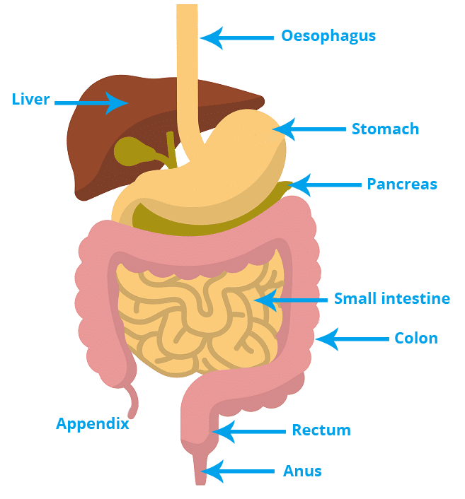
- During a digestion lesson, learners were asked to identify the organ where absoption of water and mineral salts takes place. Which one of the following organs produces was likely the correct answer?

A. Stomach B. Large intestine C. Pancreas D. Liver
- Learners observed different types of cells under a microscope. Which one of the following structures is found in a plant cell but not in an animal cell? A. Cell membrane B. Nucleus C. Chloroplast D. Cytoplasm
- Which one of the following diseases is caused by a virus? A. Tuberculosis B. Malaria C. Cholera D. HIV/AIDS
- During a discussion on preventing the spread of diseases, learners listed various methods. Which one of the following methods is used to prevent the spread of waterborne diseases? A. Using mosquito nets B. Proper disposal of waste C. Boiling drinking water D. Avoiding crowded places
- Mr. Mochama of Olalui Junior School was using a projector for his lesson,he projected the following electron arrangement on the wall.
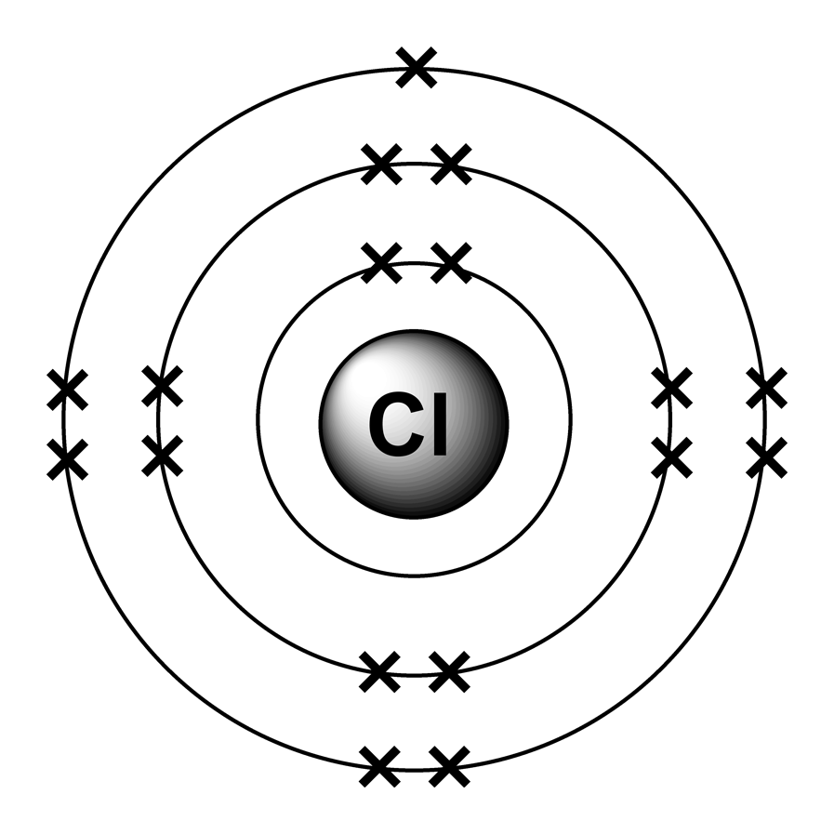
Which one of the following is the element represented? A. Sulphur B. Carbon C. Chlorine D. Aluminium
- The chemical formula for water is H_{2​}O. This indicates that a molecule of water is made up of: A. Two hydrogen atoms and one oxygen atom. B. One hydrogen atom and two oxygen atoms. C. Two atoms of hydrogen and two atoms of oxygen. D. One atom of hydrogen and one atom of oxygen.
- Which one of the following is a physical change? A. Burning of wood B. Rusting of iron C. Dissolving salt in water D. Cooking an egg
- During an experiment on chemical reactions, learners mixed two substances and observed the formation of a gas.

Which one of the following observations indicates that a chemical reaction has occurred? A. Change in state B. Change in size C. Formation of a new substance D. Change in shape
- Which one of the following is an alkaline substance? A. Lemon juice B. Vinegar C. Baking soda solution D. Pure water
- The symbol 'Na' represents the element: A. Nitrogen B. Sodium C. Neon D. Nickel
- Which one of the following separation techniques is used to separate a soluble solid from a liquid? A. Filtration B. Decantation C. Evaporation D. Sieving
- The process by which water changes from a liquid to a gas is called: A. Melting B. Condensation C. Evaporation D. Freezing
- Which one of the following is a greenhouse gas? A. Oxygen B. Nitrogen C. Carbon dioxide D. Hydrogen
- Regina was driving her car on a tarmac road.
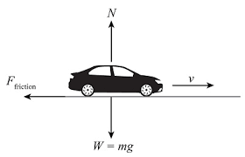
F
The force marked F that opposes motion between two surfaces in contact is called: A. Gravity B. Friction C. Weight D. Tension

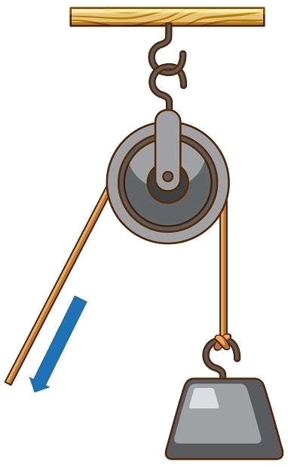
- A simple machine that consists of a wheel with a rope or cable is called a:

A. Lever B. Inclined plane C. Pulley D. Screw
- Which one of the following energy transformations occurs in a solar panel? A. Electrical energy to light energy B. Chemical energy to electrical energy C. Light energy to electrical energy D. Mechanical energy to electrical energy
- The unit of electric current is: A. Volt B. Ohm C. Ampere D. Watt
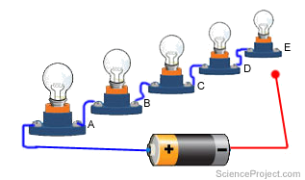
- Charity connected bulbs as shown below.

In a series circuit, what happens to the current if one bulb burns out? A. The current increases. B. The current decreases. C. The current stops flowing in the entire circuit. D. The current remains the same.
- Wambugu was testing some materials to check their electrical conductivity.
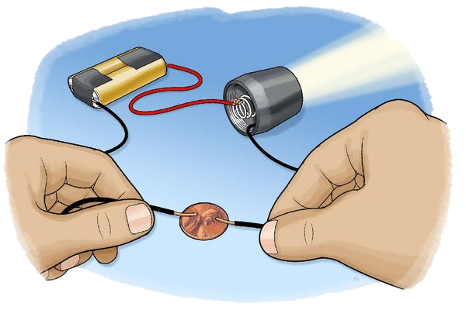
X
Which one of the following materials when placed at point X will make the bulb light?
A. Wood B. Plastic C. Glass D. Copper
- During a science fair. A learner displayed a magnet.
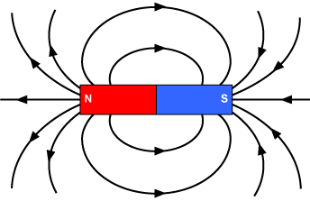
R
R
R
R
The region marked R around a magnet where magnetic force is experienced is called the: A. Magnetic pole B. Magnetic field C. Magnetic line D. Magnetic material
- Sasha did an experiment where she reacted
Hydrochloric acid (HCl) + Sodium hydroxide (NaOH) → _________________ + Water (H2O)
Apart from water, What was likely the other end products of the reaction?
A. Sodium Chloride B. Calcium Chloride C. Sodium Chloride D. Potassium Permanganate
- Which one of the following is a source of light energy? A. A mirror B. A lens C. The Sun D. A shadow
- Sound travels fastest in: A. Solids B. Liquids C. Gases D. Vacuum
- Which one of the following is a renewable source of energy? A. Coal B. Petroleum C. Natural gas D. Geothermal energy
- The boiling point of pure water at standard atmospheric pressure is: A. 0∘C B. 100∘C C. 37∘C D. −10∘C
- Which one of the following is an example of a physical property of a substance? A. Reactivity B. Flammability C. Density D. Ability to rust
- The part of a plant that absorbs water and mineral salts from the soil is the: A. Leaf B. Stem C. Flower D. Root
- Which one of the following is a product of photosynthesis? A. Carbon dioxide B. Water C. Oxygen D. Mineral salts
- A reaction between acid and base gives water and A. Ions B. Salt C. Hydroxides D. Alkaline

SECTION B (40 marks)
Answer ALL the questions in this section in the spaces provided.
- (a) Define the term 'atom' in Chemistry. (1 mark)
________________________________________________________________________
_______________________________________________________________________
(b) State the chemical symbols for the following elements:
(i) Potassium (1 mark)
________________________________________________________________________
(ii) Iron (1 mark)
________________________________________________________________________
(iii) Oxygen (1 mark)
________________________________________________________________________
(c) Explain the difference between an element and a compound. (2 marks)
________________________________________________________________________
________________________________________________________________________
________________________________________________________________________
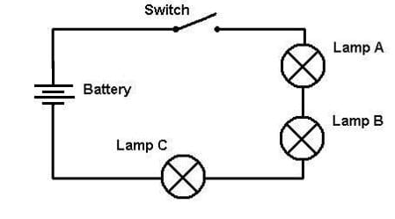
- The diagram below shows a simple electric circuit.

(a) Is the switch in the diagram open or closed? (1 mark)
_____________________________________________________________________
(b) What will happen to the bulbs when the switch is closed? (1 mark)
_____________________________________________________________________
____________________________________________________________________
(c)(i) What is pressure? (1 mark)
________________________________________________________________________
________________________________________________________________________
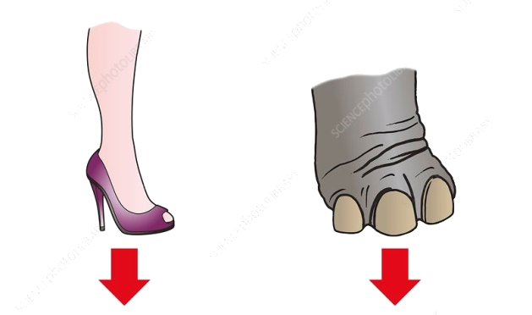
(ii) Which one exerts more pressure?(1 mark)

(iii) A rectangular block of wood measures 2.0 m long, 0.5 m wide and 0.4 m high. Its mass is 300 kg. The block is placed on a flat surface. Take the acceleration due to gravity, g, as 10 m/s².
(i) Calculate the weight of the wooden block. (1 mark)

(ii) Calculate the minimum pressure the block can exert on the surface. Show your working clearly. (2 marks)

- (a) What is reproduction? (1 mark)
________________________________________________________________________

________________________________________________________________________
(b) Write the names of the following parts. (2 marks)
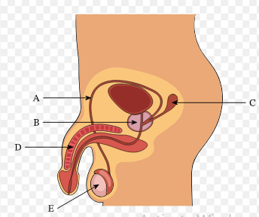
A ______________________________. E _______________________________.
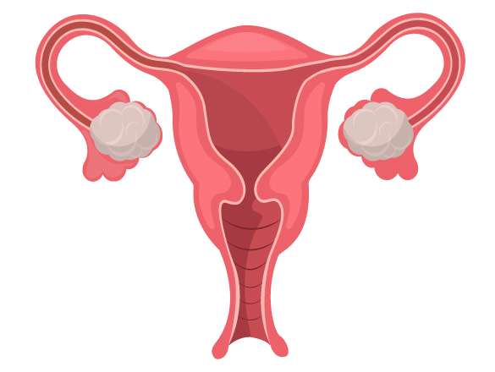
(c) Explain two functions of part M. (4 marks)

M

________________________________________________________________________

- (a) State the law of conservation of energy. (1 mark)
___________________________________________________________________________
__________________________________________________________________________
(b) Describe the energy transformation that occurs when: (i) A torch is switched on. (1 mark) ________________________________________________________________________ ________________________________________________________________________ (ii) A stone is dropped from a height. (1 mark) ________________________________________________________________________ ________________________________________________________________________
(c) Explain how heat is transferred through: (i) Conduction (2 marks) ________________________________________________________________________ ________________________________________________________________________ ________________________________________________________________________ (ii) Convection (2 marks) ________________________________________________________________________ ________________________________________________________________________ ________________________________________________________________________ (iii) Radiation (2 marks) ________________________________________________________________________ ________________________________________________________________________ ________________________________________________________________________
- (a) During a science lesson, Musere put adrop of ink in water. Later the ink had spread all over the glass. What do you call this process? (1 mark)
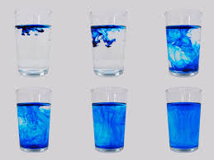
__________________________________________________________________________
__________________________________________________________________________
(b) State two factors affecting the rate of osmosis. (2 marks)
___________________________________________________________________________
___________________________________________________________________________
__________________________________________________________________________
(c) Give one importance of osmosis in living things. (1 mark)
_________________________________________________________________________
- (a) Define the term 'mixture'. (1 mark)
___________________________________________________________________________
___________________________________________________________________________
(b) Describe a method that can be used to separate a mixture of sand and iron filings. (2 marks)
__________________________________________________________________________
___________________________________________________________________________
___________________________________________________________________________
(c) Give two differences between a mixture and a compound. (2 marks)
___________________________________________________________________________
___________________________________________________________________________
___________________________________________________________________________
__________________________________________________________________________
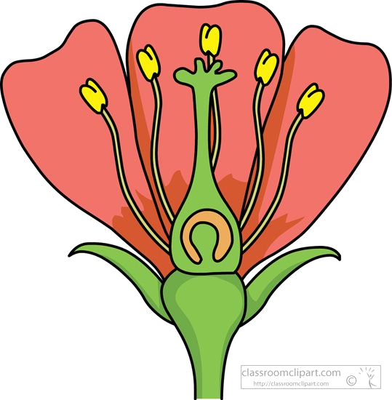
- The diagram below shows a flower.

A

B

(a) Name the part marked:
(A) _______________________________________________________ (1 mark) (B) _______________________________________________________ (1 mark)
(b) State two characteristics of insect pollinated flower. (2 marks)
________________________________________________________________________
________________________________________________________________________
________________________________________________________________________
- (a) State two reproductive parts in a flower. (2 marks)
________________________________________________________________________
________________________________________________________________________
(b) State two differences between wind pollinated flowers and insect pollinated flowers. (2 marks)
______________________________________________________________________
_____________________________________________________________________
_____________________________________________________________________
(c) Mention two modes of seed dispersal. (2 marks)
________________________________________________________________________
________________________________________________________________________
________________________________________________________________________
- (a) name the parts labeled parts of an atom (4 markS)

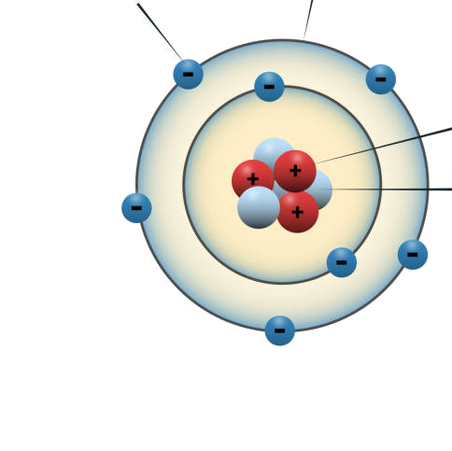
M N

O

P

M ___________________________________.
N ____________________________________.
O ____________________________________.
P ____________________________________.
(b) Identify the atomic number of the element below.(1 mark)
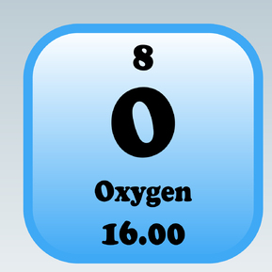
  - Atomic number: ____________________.
- (a) Define force. (1 mark)
________________________________________________________________________________________________________________________________________________
(b) State the SI unit of force. (1 mark)
________________________________________________________________________________________________________________________________________________
(c) Give two effects of a force acting on an object. (2 marks)
________________________________________________________________________________________________________________________________________________
(d) A box is pushed with a force of 50N over a distance of 10m. Calculate the work done. (Show your working) (2 marks)
________________________________________________________________________________________________________________________________________________________________________________________________________________________________________________________________________________________________
THIS IS THE LAST PRINTED PAGE

MARKING SCHEME
SECTION A (30 marks)
- B. cell
- B. Large intestine
- C. Chloroplast
- D. HIV/AIDS
- C. Boiling drinking water
- C. Chlorine (Electron arrangement 2, 8, 7 gives a total of 17 electrons, which is chlorine)
- A. Two hydrogen atoms and one oxygen atom.
- C. Dissolving salt in water
- C. Formation of a new substance
- C. Baking soda solution
- B. Sodium
- C. Evaporation
- C. Carbon dioxide
- B. Friction
- C. Pulley
- C. Light energy to electrical energy
- C. Ampere
- C. The current stops flowing in the entire circuit.
- D. Copper
- B. Magnetic field
- A. sodium chloride
- C. The Sun
- A. Solids
- D. Geothermal energy
- B. 100°C
- C. Density
- D. Root
- C. Oxygen
- B. salt
- D. diffusion
SECTION B (40 marks)
Here are the answers to the short, structured questions:
31. (a) Define the term 'atom' in Chemistry.
An atom is the smallest basic unit of a chemical element that retains the chemical properties of that element.
(b) State the chemical symbols for the following elements:
(i) Potassium: K (ii) Iron: Fe (iii) Oxygen: O
(c) Explain the difference between an element and a compound.
An element is a pure substance consisting of only one type of atom. A compound is a pure substance formed when two or more different elements are chemically combined in a fixed ratio.
32. (a) Is the switch in the diagram open or closed?
The switch in the diagram is open.
(b) What will happen to the bulbs when the switch is closed?
When the switch is closed, the circuit will be complete, and the bulbs will light up.
(c)(i) What is pressure?
Pressure is the force exerted per unit area.
(ii) Which one exerts more pressure?
The high heel shoes, high pressure concentrated on a small area.
(iii) A rectangular block of wood measures 2.0 m long, 0.5 m wide and 0.4 m high. Its mass is 300 kg. The block is placed on a flat surface. Take the acceleration due to gravity, g, as 10 m/s².
(i) Calculate the weight of the wooden block.
Weight (W) = mass (m) × acceleration due to gravity (g) W = 300 kg × 10 m/s² W = 3000 N
(ii) Calculate the minimum pressure the block can exert on the surface. Show your working clearly.
Pressure (P) = Force (F) / Area (A)
The minimum pressure will be exerted when the block is placed on its largest surface area.
The dimensions of the surfaces are:
Surface 1: 2.0 m × 0.5 m = 1.0 m² Surface 2: 2.0 m × 0.4 m = 0.8 m² Surface 3: 0.5 m × 0.4 m = 0.2 m²
The largest area is 1.0 m². The force exerted on the surface is the weight of the block (3000 N).
Minimum Pressure = 3000 N / 1.0 m² Minimum Pressure = 3000 N/m² or 3000 Pascals (Pa)
33. (a) What is reproduction?
Reproduction is the biological process by which new individual organisms ("offspring") are produced from their "parents".
(b) Write the names of the following parts.
A. sperm duct/vas deferens. E. testis.
(c) Explain two functions of part M.
- Receive sperms/semen/deposition of semen/sperms
- Path for child during birth
34. (a) State the law of conservation of energy.
The law of conservation of energy states that energy cannot be created or destroyed, but it can be transformed from one form to another or transferred between objects. The total amount of energy in a closed system remains constant.
(b) Describe the energy transformation that occurs when:
(i) A torch is switched on.
Chemical energy stored in the batteries is transformed into electrical energy, which is then transformed into light energy and heat energy in the bulb.
Chemical electrical heat light
(ii) A stone is dropped from a height.
Potential energy (due to its height) is transformed into kinetic energy (energy of motion) as it falls. Some energy is also converted into sound energy and a small amount of heat energy due to air resistance.
potential kinetic sound heat

(c) Explain how heat is transferred through:
(i) Conduction: Conduction is the transfer of heat through direct contact between particles of a substance without the movement of the particles themselves. Heat energy is transferred from hotter, more energetic particles to cooler, less energetic adjacent particles through vibrations and collisions. This occurs mainly in solids.
(ii) Convection: Convection is the transfer of heat through the movement of fluids (liquids or gases). When a fluid is heated, it becomes less dense and rises, carrying the heat energy with it. Cooler, denser fluid sinks to replace it, creating a循环 (circulation) of heat.
(iii) Radiation: Radiation is the transfer of heat through electromagnetic waves. Unlike conduction and convection, radiation does not require a medium and can occur through a vacuum. All objects emit thermal radiation, and the amount and type of radiation depend on the object's temperature and surface properties.
35. (a) During a science lesson, Musere put a drop of ink in water. Later the ink had spread all over the glass. What do you call this process?
This process is called diffusion.
(b) State two factors affecting the rate of osmosis.
Two factors affecting the rate of osmosis are:
- The concentration gradient (difference in water potential) across the semi-permeable membrane.
- The surface area of the semi-permeable membrane.
- Water Potential (Concentration Gradient):
The greater the difference in water potential (or solute concentration) between two solutions separated by a semipermeable membrane, the faster the rate of osmosis.
Water moves from a region of high water potential (low solute concentration) to a region of low water potential (high solute concentration) to equalize the concentration.
- Temperature:
Higher temperatures increase the kinetic energy of water molecules, leading to faster movement and thus a higher rate of osmosis.
Conversely, lower temperatures slow down the movement of water molecules, reducing the rate of osmosis.
- Surface Area of the Membrane:
A larger surface area of the semipermeable membrane provides more space for water molecules to move across, increasing the rate of osmosis.
A smaller surface area restricts movement and slows down the process.
- Presence of Aquaporins:
Aquaporins are protein channels in cell membranes that facilitate the rapid passage of water molecules.
The presence of aquaporins can significantly increase the rate of osmosis, as water can move through these channels more easily than through the lipid bilayer of the membrane.
- Membrane Permeability:
The permeability of the membrane to both water and solutes influences the rate of osmosis.
- Osmotic Pressure:
The pressure required to stop the movement of water across a semipermeable membrane is known as osmotic pressure.
- Viscosity:
Higher viscosity (thickness) of the solution can slow down the rate of osmosis.
- Pressure:
Applying external pressure can influence the direction and rate of osmosis, particularly in processes like forward osmosis.

(c) Give one importance of osmosis in living things.
Osmosis is essential for the absorption of water by plant roots from the soil.
Nutrient and Waste Transport:
Water Homeostasis:
It plays a key role in maintaining the right balance of water and solutes within cells, crucial for their proper functioning.
Cell Turgidity:
Osmosis helps maintain the turgor pressure in cells, which is essential for plant cell structure and movement.
Plant Water Absorption:
Osmosis allows plants to absorb water from the soil, which is then transported throughout the plant.
Osmosis helps move essential nutrients into cells and allows for the removal of metabolic waste products.
Protection Against Drought:
By increasing osmotic pressure, osmosis helps plants resist the effects of drought.
Kidney Function:
In animals, osmosis is important for kidney function, helping to regulate water balance and waste removal.
Sweat Regulation:
Osmosis also plays a role in sweat production, which helps regulate body temperature.
36. (a) Define the term 'mixture'.
A mixture is a substance comprising two or more components not chemically bonded.
(b) Describe a method that can be used to separate a mixture of sand and iron filings.
A mixture of sand and iron filings can be separated using magnetic separation. A magnet is brought close to the mixture. The iron filings, being magnetic, will be attracted to the magnet and can be easily separated from the non-magnetic sand.
(c) Give two differences between a mixture and a compound.
Feature | Mixture | Compound
Formation | Physically combined, no chemical reaction | Chemically combined in a fixed ratio
Composition | Variable proportions of components | Fixed proportions of elements
Properties | Retains the individual properties of components | Has properties different from its constituent elements
Separation | Can be separated by physical means | Can only be separated by chemical means
37. (a) Name the part marked:
(You would need to see the diagram of the flower to label parts A and B.)
(A) stigma (B) petals
(b) State two characteristics of an insect-pollinated flower.
Two characteristics of insect-pollinated flowers are:
- They often have brightly colored petals to attract insects.
- They may produce nectar and/or have a scent to lure insects.
38. (a) State two reproductive parts in a flower.
Two reproductive parts in a flower are:
- Stamen (male reproductive part, consisting of the anther and filament)
- Pistil/Carpel (female reproductive part, consisting of the stigma, style, and ovary)
(b) State two differences between wind-pollinated flowers and insect-pollinated flowers.
Feature | Wind-pollinated flowers | Insect-pollinated flowers
Petals | Usually small, dull, or absent | Often large and brightly colored
Pollen | Produce large quantities of light, dry pollen | Produce smaller quantities of sticky or spiky pollen
Stigma | Large and feathery to catch windborne pollen | Often sticky to receive pollen carried by insects
Nectar/Scent | Usually absent | Often present to attract insects
(c) Mention two modes of seed dispersal.
Two modes of seed dispersal are:
- Wind dispersal (anemochory)
- Water dispersal (hydrochory)
- Animal dispersal (zoochory)
- Self Explosion mechanisms (autochory)
39. (a) Name the parts labeled parts of an atom.
(You would need to see the diagram of the atom to label parts M, N, O, and P. Common labels include protons, neutrons, electrons, and the nucleus.)
M. electrons N. energy level/outer shell O. protons P. neutrons
(b) Identify the atomic number of the element below.
(The atomic number is the number of protons in the nucleus.
a. Atomic number: 8.
40. (a) Define force.
Force is a push or a pull that can cause an object to accelerate, change direction, or change shape.
(b) State the SI unit of force.
The SI unit of force is the Newton (N).
(c) Give two effects of a force acting on an object.
Two effects of force acting on an object are:
- It can cause a stationary object to start moving or a moving object to stop or change its speed.
- It can cause a moving object to change its direction.
- It can cause an object to change its shape or size.
(d) A box is pushed with a force of 50N over a distance of 10m. Calculate the work done. (Show your working)
Work done (W) = Force (F) × Distance (d) × cos(θ)
Assuming the force is applied in the direction of motion, θ = 0°, and cos(0°) = 1.
W = 50 N × 10 m × 1 W = 500 Joules (J)

