Candidate’s Name: ………………………………………………………… Assessment Number: …………………………………………
School Name: ……………………………………………………………………. School Code: …………………………………………………………
Candidate’s Signature: ………………………………..…………….Date: …………………………………………………….…………….
COMPETENCE BASED EDUCATION
KENYA JUNIOR SCHOOL EDUCATION ASSESSMENT
907: SOCIAL STUDIES
YEAR 20__
Time: 1 Hour 30 Minutes
INSTRUCTIONS TO CANDIDATES
- Write your name and assessment number correctly.
- Write the name and code of your school in the spaces as indicated above.
- Write the date of the assessment.
- This paper consists of two sections: A and B.
- Section A comprises Multiple choice Questions.
- Section B comprises structured questions and essay questions.
- Answer ALL the questions in Section A on the separate ANSWER SHEET provided.
- Answer ALL the questions in Section B in the spaces provided on this question paper.
- Do NOT remove any page from this question paper.
- Answer the questions in English.
For official use only
Metric | 28 | 30 | 23 | 25 | 26 | 32 | 21 | 24 | 29 | 22 | 27 | 31 | 33 | 34
Task |  | T1 | T1 | T1 | T1 | T2 | T2 | T2 | T3 | T3 | T3 | T4 | T4 | T4
Candidate’s Score per Question
Maximum Score |  | 9 |  | 21 |  |  |  | 25 |  |  | 25
Candidate’s Score per Task
This paper consists of 14 printed pages. Candidates should check the question paper to ascertain that all the pages are printed as indicated and that no questions are missing.
© 2025 The Competence Based Assessment Turn Over

SECTION A
- You have been given this question paper and a separate answer sheet. Answer all the questions in Section A on the separate answer sheet provided.
- When you have chosen your answer, mark it on the ANSWER SHEET, not on this question paper.
HOW TO USE THE ANSWER SHEET
- Use an ordinary HB pencil.
- Confirm that the answer sheet you have been provided with has the following:
YOUR ASSESSMENT NUMBER YOUR NAME
NAME OF YOUR SCHOOL NAME OF THE SUBJECT
- Keep the answer sheet clean, and dry and DO NOT fold it.
- For each of the questions 1 – 20, four answers are given. The answers are lettered A, B, C and D. In each case, only ONE of the four answers is correct. Choose the correct answer.
- On the answer sheet, the correct answer is to be shown by drawing a dark line inside the box in which the letter you have chosen is written.
Example
In the Question Booklet:
- Your class is planning to start an enterprise project in the school. The first activity the class should do is to:
A. agree on how to share the profits from the project B. agree on roles during the project C. discuss where to sell the products D. discuss the type of project to start.
The correct answer is ‘D’.
On the answer sheet, in the set of boxes given for number 17, draw a dark line inside the box with the letter D printed in it as indicated below.
17. [A] [B] [C] [D]
- Your dark line MUST be inside the box.
- For each question, ONLY ONE box is to be marked in each set of four boxes.
SECTION A (20 marks)
Answer ALL the questions in this section.

- One of the key reasons for studying Social Studies is to understand human interactions and societies. Which of the following is also a major reason for studying the subject? A. To learn how to perform scientific experiments. B. To master mathematical calculations. C. To develop an appreciation for diverse cultures and perspectives. D. To acquire skills in foreign languages.
- Gender equality is important for the progress of any society. Which of the following actions would least promote gender equality? A. Encouraging girls to pursue careers in Science and Technology. B. Allocating leadership roles in a balanced way regardless of gender. C. Discouraging women from participating in community decision-making. D. Challenging traditional beliefs that assign rigid roles based on gender.

- Different instruments are used to measure weather elements. Which element is measured using a thermometer? A. Rainfall B. Atmospheric pressure C. Temperature D. Wind speed
- At 12:00 noon, Amina in Mombasa 40°E calls her friend David in Lagos 3°E. What time will it be in Lagos? A. 9:48 am B. 10:12 pm C. 2:12 pm D. 11:57 am

- Africa is often referred to as the cradle of humankind. Besides the discovery of numerous ancient fossils and tools, which other factor strongly supports this theory? A. The presence of large river systems like the Nile. B. The continent's central location on the globe. C. The discovery of diverse plant and animal species. D. The findings from genetic studies of human populations.

- Religious accounts provide one explanation for the origin of human beings. Another significant explanation is the theory of creationism. This theory posits that: A. Human beings evolved from apes over millions of years. B. Life and the universe were created by a divine being. C. Human beings originated from a single location in Africa. D. Humans were created through random biological processes.

- Achieving social peace within a community is essential for harmony. One effective way to promote social peace is by: A. Insisting on your own way in disagreements. B. Spreading rumours about people you dislike. C. Practising tolerance and respect for others' views. D. Avoiding communication with people from different backgrounds.

- Grade 7 learners studied the economic activities of the Maasai and the Samburu up to the 19th century. Give a common economic activity practised by these two communities. A. Fishing B. Pastoralism C. Crop farming D. Mining
- The scramble and partition of Africa led to the colonisation of the continent by European powers. From the table shown, select the colonial power that is correctly matched with its colony.
Country Colony A Portugal - Congo B Germany -Mozambique C France -Algeria D Italy -Gold Coast
- To develop self-awareness, which is crucial for personal growth, one should strive to: A. Ignore feedback from others. B. Reflect honestly on one's strengths and weaknesses. C. Always agree with what others say about you. D. Compare one-self unfavourably with peers.
- Grade 9 learners used online resources to research on modern forms of servitude. From the options below, choose the type of servitude where people are forced to work to pay off a debt, often with unfair terms. A. Forced labour B. Child marriage C. Debt bondage D. Human trafficking

- The ancient kingdom of Mali was known for its wealth, largely derived from Trasn-saharan Slave trade. Which valuable commodity was a key export from Mali? A. Ivory B. Gold C. Spices D. Slaves
- Barter trade was the earliest form of exchange before the introduction of money. Which of the following was a major limitation of barter trade? A. It was difficult to carry large quantities of goods. B. There was no agreement on the value of goods. C. It required a double coincidence of wants. D. It was only practised over short distances.
- Positive values are important for maintaining healthy relationships in the school and community. Which of the following actions is likely to hinder healthy relationships? A. Practising empathy towards others. B. Engaging in gossip and rumour-mongering. C. Showing kindness and compassion. D. Respecting the opinions of others.

- A community health worker discussed situations that may lead to conflicts in the community. Select a situation that is least likely to cause community conflicts from the options provided. A. Land disputes. B. Religious intolerance. C. Equitable distribution of resources. D. Political disagreements.
- Different types of maps are used for various purposes. Which type of map primarily shows detailed physical and human features using contour lines and symbols? A. Sketch map B. Cadastral map C. Atlas map D. Topographical map
- Grade 8 learners conducted a field study to investigate farming methods used in a nearby rural area. Give the most suitable method of data collection they would use to observe and record the different methods. A. Interviewing farmers. B. Using a questionnaire. C. Direct observation. D. Analysing secondary data.
- Sarah was born in Kenya to Kenyan parents. She later moved to Canada and became a Canadian citizen through naturalisation. Which type of citizenship does she currently possess? A. Citizenship by birth. B. Citizenship by registration. C. Dual citizenship. D. Citizenship by descent.

- The Indian Ocean Trade had both positive and negative effects on the East African coast. Identify one positive economic effect of this trade. A. Introduction of new crops. B. Spread of Islam. C. Rise of city-states. D. Increased slave trade.
- Learners prepared a chart on factors influencing population distribution in Africa. Identify one factor they are likely to have come up with. A. Availability of social amenities. B. High birth rates. C. Migration out of Africa. D. Improved healthcare.

SECTION B (80 marks)
Answer ALL questions in this section.
- A Social Studies teacher used the sketch map provided to facilitate a lesson on map reading and interpretation.
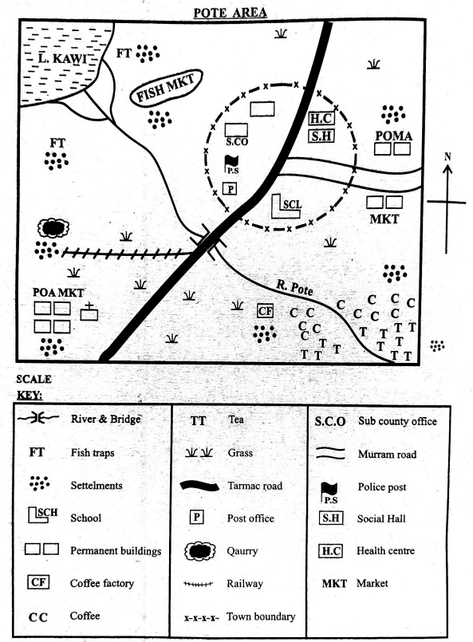

a) The teacher asked the learners to give the direction one would take when walking from the bridge to Lake Kawi. The direction is

_____________________________________________________________ (1 mark)
b) During the lesson, the teacher asked the learners to measure the total distance of the tarmac road. Give the distance in kilometres.
(Show your working) (2 marks)
(Use your set ruler whose measurements are provided)
(scale 1cm rep 2km)

c) The learners studied some human activities carried out in the area depicted by the map. Name four of these activities as shown by the map symbols or features. (4 marks)
__________________________________________________________________________

__________________________________________________________________________

__________________________________________________________________________
_________________________________________________________________________
d) The learners were asked to discuss the types of natural features found in the area. Identify three types of natural features that they discussed based on the map. (3 marks)
_______________________________________________________________________

_______________________________________________________________________
_______________________________________________________________________

- Human rights are fundamental to the dignity and well-being of all individuals. Identify five economic rights as contained in international human rights instruments. (5 marks)
_____________________________________________________________________________

_____________________________________________________________________________

_____________________________________________________________________________

_____________________________________________________________________________
____________________________________________________________________________
- Different types of migration take place across the globe.
a) Identify three types of international migration. (3 marks)
____________________________________________________________________________

___________________________________________________________________________
___________________________________________________________________________
b) Outline three negative effects of rural-urban migration on the urban areas in Africa. (3 marks)
_____________________________________________________________________________

____________________________________________________________________________
_____________________________________________________________________________
- Grade 7 learners watched a documentary on the methods of food preservation used by early communities.
a) Identify two traditional methods of food preservation they observed in the documentary. (2 marks)
_____________________________________________________________________________
_____________________________________________________________________________
b) Give three reasons why early human beings needed to preserve food. (3 marks)
___________________________________________________________________________
____________________________________________________________________________
_____________________________________________________________________________
- The members of the Peace Club in the school discussed methods used to prevent conflicts from escalating. Outline two of the methods they are likely to have discussed. (2 marks)
_____________________________________________________________________________
_____________________________________________________________________________
- The interaction between African communities and outsiders led to cultural exchange. State three ways in which African cultures have influenced the modern world. (3 marks)
_____________________________________________________________________________

_____________________________________________________________________________
_____________________________________________________________________________
- During a career day session, learners were guided on career opportunities associated with Social Studies. Outline five of these careers, excluding teaching. (5 marks)
_____________________________________________________________________________

_____________________________________________________________________________

_____________________________________________________________________________

_____________________________________________________________________________
_____________________________________________________________________________

- Learners interacted with a story about honesty and integrity. Highlight five positive values that are important for building trust in relationships. (5 marks)
_____________________________________________________________________________

_____________________________________________________________________________

_____________________________________________________________________________

_____________________________________________________________________________
_____________________________________________________________________________
- Grade 8 learners visited a museum to study sources of historical information that have been preserved over the years.
a) Identify two types of written sources of historical information that they studied. (2 marks)
_____________________________________________________________________________

____________________________________________________________________________

b) Below are certain Africa’s historical sites. Name them and site their location. (6 marks)
 | 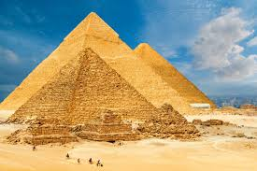 | 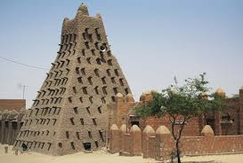 | 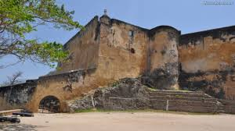
Name
country located
c) Explain two ways in which oral traditions help historians to reconstruct the history of communities that did not have written records. (2 marks)
_____________________________________________________________________________
_____________________________________________________________________________
_____________________________________________________________________________
_____________________________________________________________________________
- Members of the Social Studies club discussed the challenges of African slaves underwent during Indian Ocean Slave Trade. Outline four political causes of points likey to be mentioned. (4 marks)
____________________________________________________________________________

____________________________________________________________________________

___________________________________________________________________________
____________________________________________________________________________
- During a geography lesson, grade 9 learners discussed causes of earth movements. They stated that there are some factors that can cause earthquake and formation of new geographical features.
a) State one causes of earth movements. (1 marks)
_____________________________________________________________________________

_____________________________________________________________________________

b) Who advanced the theory of continental drift? (1 mark)
_____________________________________________________________________________

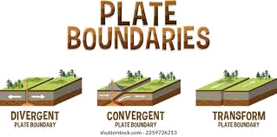
c) Name the following plate boundaries. ( 2 marks)

a ____________________________ b_________________________
- Grade 8 learners discussed the causes and effects of population change in Africa.
(a) Highlight four causes of population decline that they are likely to have discussed. (4 marks)
_____________________________________________________________________________

_____________________________________________________________________________

_____________________________________________________________________________
_____________________________________________________________________________
b) Explain how each of the following factors discussed influence population distribution in Africa:
(i) Vegetation (2 marks)

_____________________________________________________________________________

_____________________________________________________________________________
(ii) Soils (2 marks)

_____________________________________________________________________________

_____________________________________________________________________________

(iii) Relief (2 marks)
_____________________________________________________________________________

_____________________________________________________________________________

- Responsible citizenship involves active participation in community affairs. State three ways in which learners can demonstrate responsible citizenship within the school compound. (3 marks)
___________________________________________________________________________

_____________________________________________________________________________
_____________________________________________________________________________
- A Grade 9 teacher used a map shown to facilitate learning on a major physical feature in Africa. Use it to answer questions a and b.
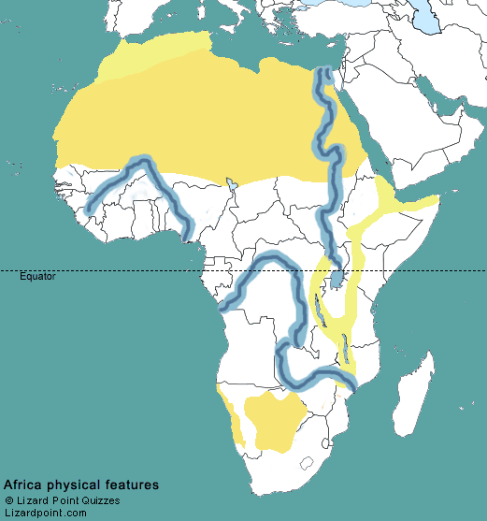

M

N

a) (i) Identify the geological feature marked X on the map. (1 mark)
_________________________________________________________________
ii) Name the process that led to the formation of this feature. (1 mark)
_____________________________________________________________________________
b) Identify the physical features marked Desert M and River N. (2 marks)

M: ____________________________. N: ____________________________.
c) on the map locate the following. (2 marks)
i) Tropic of cancer ii) Prime meridian
- Study the picture below carefully.
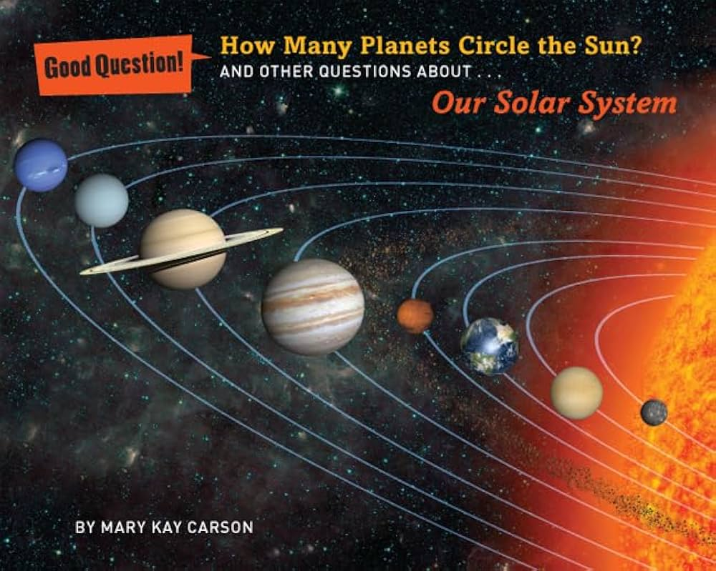
W

- What is the name of planet marked W? ( 1 mark)
___________________________________________
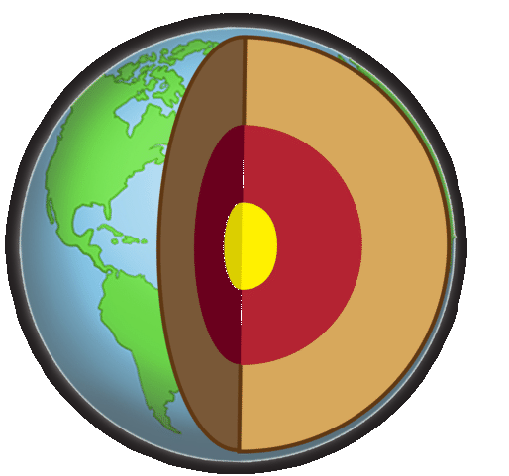
- Study the diagram below.

T

Identify the region marked T. (1 mark)
______________________________.
THIS IS THE LAST PRINTED PAGE

MARKING SCHEME
SECTION A (20 MARKS)
- C. To develop an appreciation for diverse cultures and perspectives.
- C. Discouraging women from participating in community decision-making.
- C. Temperature
- A. 9:48 am
- D. The findings from genetic studies of human populations.
- B. Life and the universe were created by a divine being.
- C. Practising tolerance and respect for others' views.
- B. Pastoralism
- C France - Algeria
- B. Reflect honestly on one's strengths and weaknesses.
- C. Debt bondage
- B. Gold
- C. It required a double coincidence of wants.
- B. Engaging in gossip and rumour-mongering.
- C. Equitable distribution of resources.
- D. Topographical map
- C. Direct observation.
- C. Dual citizenship.
- C. Rise of city-states.
- A. Availability of social amenities.
SECTION B (80 marks)
21. a) North East
b) Working: 15.5 cm x 2 km/cm = 31 km
c) Farming,mining,fishing,construction, administration, Settlement,transport and Communication (roads), Trade (market)
d) River, Hill, Lake,river,vegetation like grass

  - The right to work
  - The right to fair wages
  - The right to social security
  - The right to an adequate standard of living
  - The right to form and join trade unions
- a) * Voluntary migration * Forced migration * Labour migration b) * Overcrowding * Increased unemployment * Strain on social amenities
- a) * Sun drying * Smoking b) * To ensure food availability during off-seasons * To prevent food spoilage * To facilitate storage for future use

  - Encouraging dialogue and negotiation
  - Mediation and arbitration

  - Music and dance
  - Art and crafts (e.g., beadwork, sculptures)
  - Traditional medicine knowledge

  - Anthropologist
  - Archaeologist
  - Geographer
  - Historian
  - Political Scientist

  - Honesty
  - Respect
  - Empathy
  - Fairness
  - Trustworthiness
- a) * Diaries * Letters * Official documents * Books
b) Below are certain Africa’s historical sites. Name them and site their country of location. (6 marks)
Name | Great Pyramids of Giza | Timbuktu | Fort Jesus
country located | Egypt | Mali | Kenya
C) * They preserve historical accounts and memories of communities without written language.
* They provide diverse perspectives and interpretations of past events from the people who experienced them.
* They can offer insights into social structures, cultural practices, and belief systems that may not be documented elsewhere.
* They can be used to corroborate or challenge information from other historical sources.
* They contribute to the collective identity and heritage of communities by passing down knowledge through generations.
* They can highlight the experiences and contributions of marginalized groups whose stories might be absent from written records.

  - Political instability and conflicts
  - Expansionist ambitions of rulers
  - Weak leadership in some communities
  - External interference and alliances

  - Isostatic adjustments
  - Human activities
  - Meteorite falls
  - Gravitational pull
  - Magma movement within the crust
  - Convectional currents
b) Who advanced the theory of continental drift? (1 mark)
Alfred Wagner

c) Name the following plate boundaries. ( 2 marks)

a divergent plate boundary b. convergent plate boundary

- a)
* High mortality rates due to diseases
* Famine and drought
* Wars and conflicts
* Emigration
b) (i) Vegetation: Areas with dense vegetation like forests may have sparse populations due to difficulties in clearing land for settlement and agriculture. Grasslands and areas with moderate vegetation tend to support higher populations due to agricultural potential and grazing. (ii) Soils: Fertile soils that support agriculture attract higher populations as people settle in these areas for farming. Areas with poor or infertile soils tend to have lower population densities.
(iii) Relief: Flat or gently sloping areas are generally more densely populated as they are suitable for settlement, agriculture, and infrastructure development. Rugged or mountainous areas tend to have lower populations due to difficulties in accessibility and cultivation.

  - Participating in school clean-up activities
  - Respecting school rules and regulations
  - Reporting cases of bullying or vandalism
- a) (i) Rift Valley
(ii) Tectonism/Faulting
b) M: Sahara Desert, N: River Nile
c) (i) Located approximately 22.5 degrees North of the Equator.
(ii) Located at 0 degrees Longitude.
- Planet marked W: Saturn
- Region marked T: inner core

